The Hub for Young Next-gen Knowledge

Download and install Scratch. If you are using Microsoft Windows – click on the "Windows – Download".
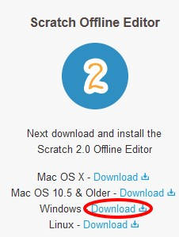
After the installation a nice icon will appear on your desktop.
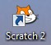
Scratch on!
Introduction for Children. How to work with the book.
This book is not organized as a traditional textbook. I will not explain anything about programming. You will immediately start making games. While making games, you will learn how to program. Each step in the creation of games is depicted in the pictures. Do everything very carefully, and your game will work immediately. You can play them, and also show the game to your parents and friends. After the game is programmed, I'll explain how it works. You can change each game a little bit. When you change each game, you will have a good idea of how they work and learn programming very quickly. You can create your own game. Sometimes you will have a lot to draw with the mouse. Do not worry if you get ugly drawings. I do not know how to draw beautifully. If you practice, you will learn how to paint beautifully. You will learn very well, if you know how to count to 1000, and know how to multiply two‐digit numbers. If not, you can still start making games. Mathematical concepts that you need are explained in the application. Go ahead! Program with Scratch! It is easy!
Chapter 1. How Scratch is built. The first program.
Start Scratch from your icon on the desktop.

Press the square in the top right corner in order to expand Scratch to take up the whole screen. Now you can see very well that Scratch has three parts.
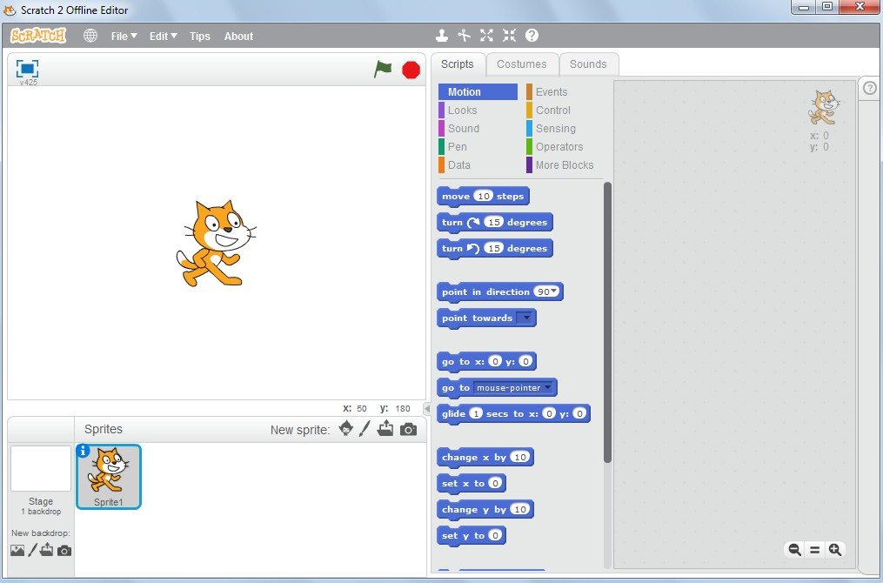
There is a bunch of blue blocks in the center.
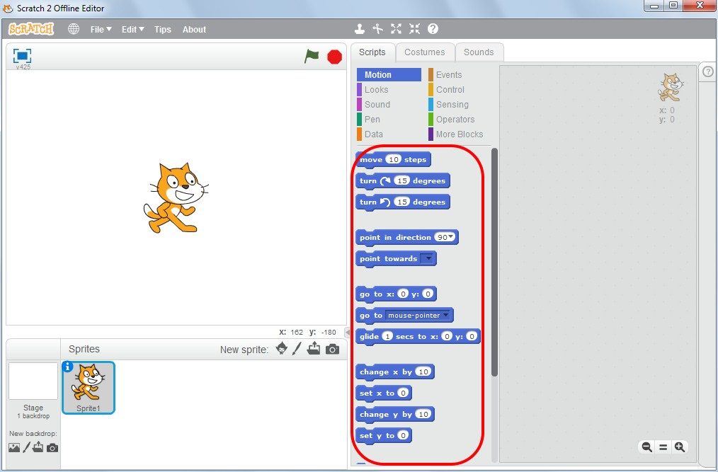
On the left side there is the Stage, where the program will run.
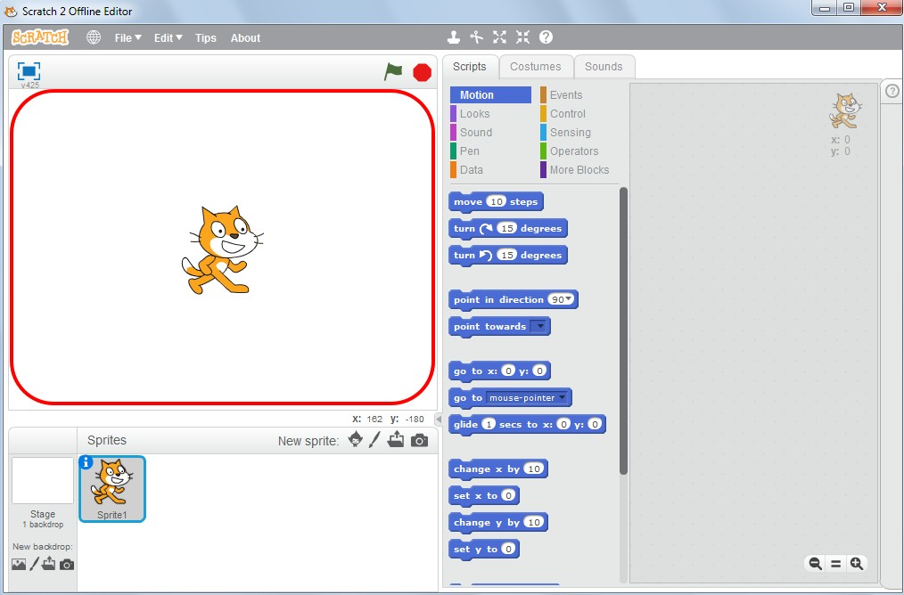
At the moment we have only one character — a cat named Sprite1. Characters in Scratch are called sprites. I believe the famous soda water is to blame.

This area we will call the sprite area.
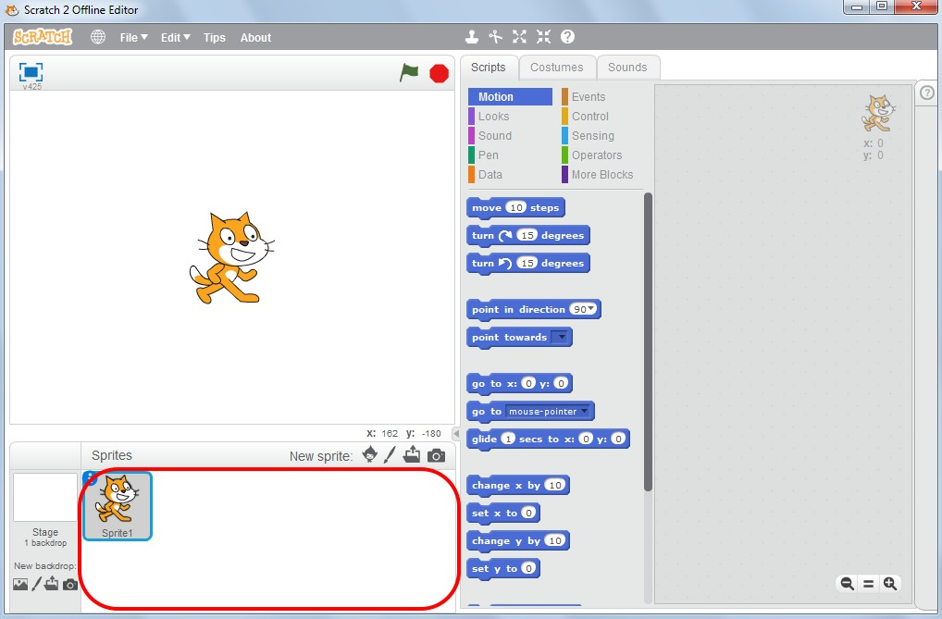
At the right corner there is a grey blank place. There we will make a program out of blocks. This is a working area or scripts area.
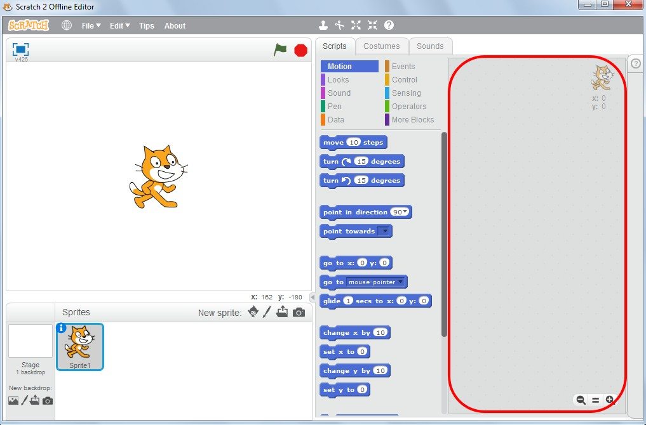
The basis for Scratch is made of multi‐colored blocks. We will mainly use blue, yellow, violet and light‐blue blocks. Here are the blue blocks.
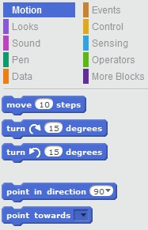
Here are the yellow blocks.
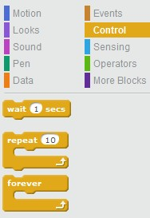
Here are the violet blocks.
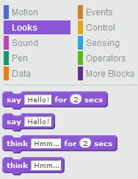
I will tell you more about the functions of all the remaining buttons of Scratch while you are programming. Now let’s teach the Kitten to run.
Select the "Events" blocks and drag the block "with the spacebar pressed" to the center of the screen and drop it there. To drag the block, press on it and hold the spacebar while dragging.
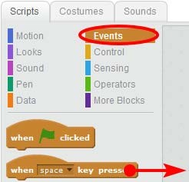
Drag the block to the right and drop it by releasing the mouse button.
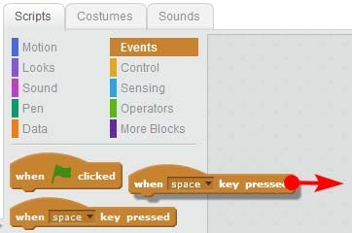
Now select the blue "Motion" blocks and drag the "move 10 steps" block to the right.
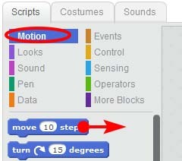
Fix it under the brown block "by pressing the space key ".
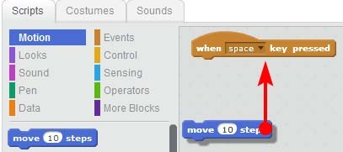
When the blue block is ready to be attached to the brown one – there is a white strip visible. Release the mouse button and it will be attached.
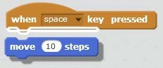
Well done! You’ve managed to create your first program or script as some may call it.
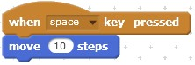
Press the Spacebar and watch how the kitten is moving.
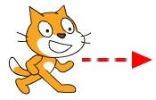
If you keep on clicking, he will go to the edge of the screen and will hide there. The tail will be still visible.

And that is how you bring it back. Press on its tail and drag the Cat back to the center of the stage. Then press spacebar again to move the Cat to the right.
Drag it to the left side of the stage and answer the question, how many times did you press the spacebar to move the Cat to the right edge of the screen?

I managed to press it 40 times. Forty times per 10 steps or a total of four hundred. The screen is nearly 400 steps wide. Remember this number.
Let’s add a "Meow" sound to our program. Press the crimson "Sound" blocks and drag the "play sound meow" block under the "move 10 steps" blue block.
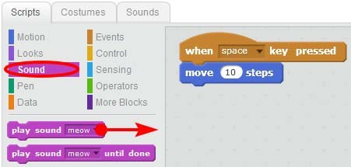
Attach the crimson block to the bottom.
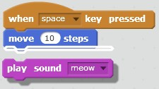
Now the Cat is moving and meowing when you press spacebar.
If he meows too loudly, adjust the volume by pressing the volume icon in the right bottom corner of your Windows screen as you usually do.
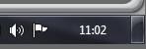
If you are bored with his meowing, you may add new sounds. For instance, you can make him bark!

First you have to go to the "Sounds" tab.
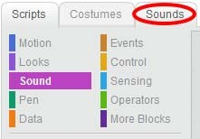
Then press the "Choose sound from library" button.
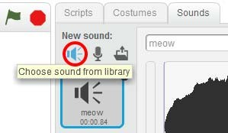
The sound library will appear. It is where you can find several types of sounds. Select "Animals".
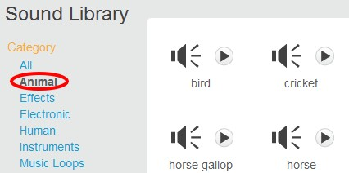
All other sounds will disappear and there will be animal sounds only. You can listen to the sounds first by pressing the triangle in the circle similar to the "Play" button in your music player.
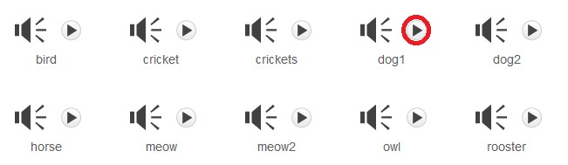
Click on different files, listen to the animal’s sounds, and imagine you are on holidays in the countryside. Then select the "Dog1" sound and click "OK".
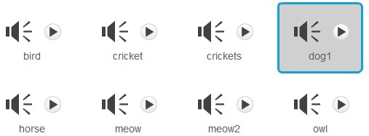
The "OK" button is in the bottom.

Now we can use two different sounds for the Cat.
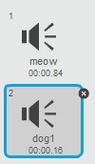
Go to the "Scripts" tab and then click on the triangle in "play sound meow" block and select the "Dog1" sound.
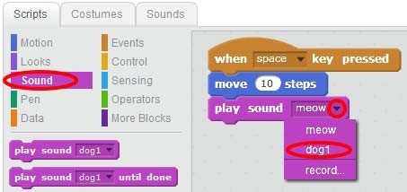
See what you have now! Press the spacebar and watch the Cat walking and barking!
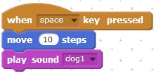
The first chapter is coming to an end, so let’s save your project. Click "File".
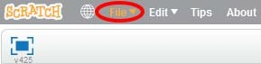
Then click "Save".
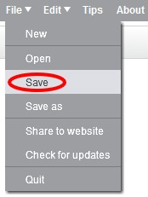
You will see the save window where you have to enter a file name. Type "First Program" and press Enter. After the program is saved, you can run it anytime by clicking "Open".
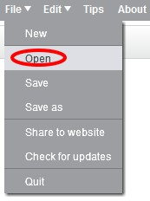
You just need to select your project in the list and press "Open".
Chapter 2. Making the first program more expanded.
Now we have this program.

If you are bored with the barking of the Cat, delete the crimson "Play sound dog1" block. Press that block and drag it to the bottom and drop it. The crimson block is now unattached.
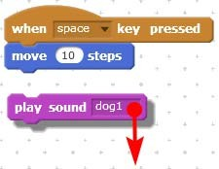
Then drag it to the left side of the screen where the other blocks are and drop it there. It will disappear.
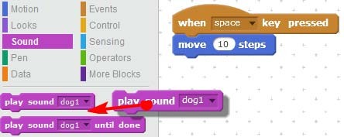
Now you have a program for silent cat’s movement. Press spacebar – the Cat will move silently. Let’s add blue block named "if on edge, bounce".
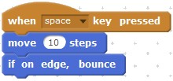
Now cat moves to the screen edge, pushes off, turns back and stands on his head.
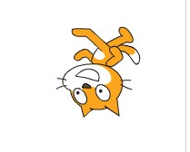
If you hold the spacebar, Cat will move between sides and reverse all the time. Let's try to modify the program. Replace figure 10 in the block 101 Steps Forward with figure. To do that you need to click figure 10 twice to make it blue.
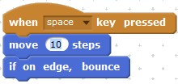
Type 1 and Enter.
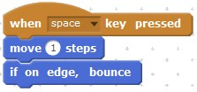
If you press spacebar now your cat will be moving slower! He makes one small step each time you press the key. Now you can have fun and insert different figures, for example, figure number 5.
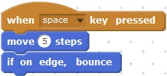
The bigger figure you select, the quicker the cat will move. Watch how he reacts to your pressing of the key. One student played around and wrote 1 and one hundred zeros in there!

